Setting in the platform Arduino the Firmware Gateway Single Channel

File

loraModem.h

Pins Define to ESP32 ⇔ RFM95
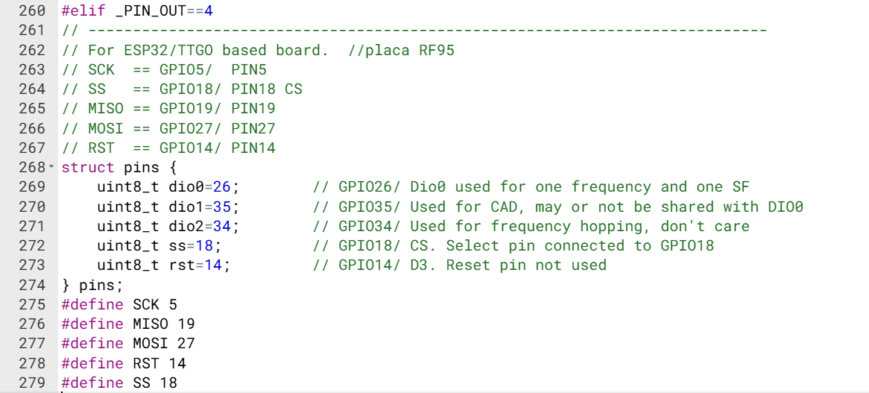

Find your Gateway Device Channel in the main file ESP_sc_gateway.ino
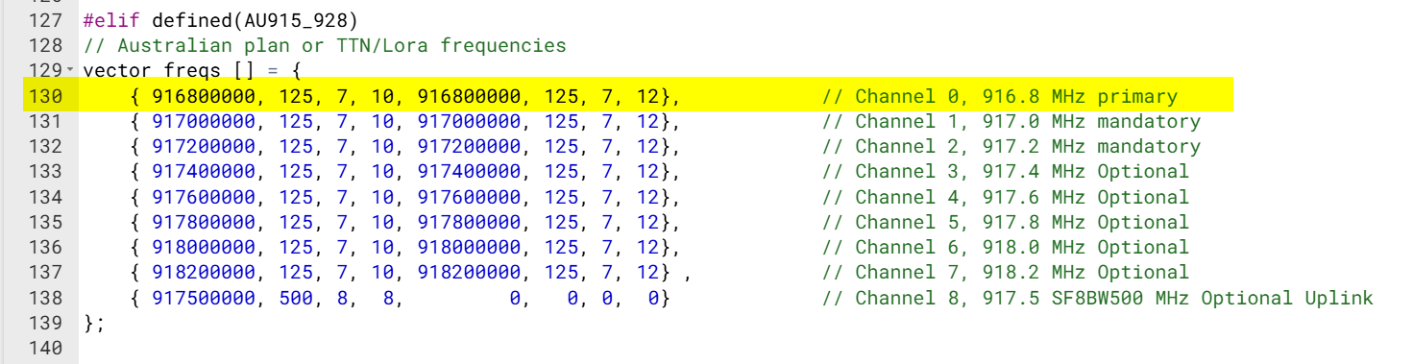

File
configNode.h

Wi-Fi SSID & Password
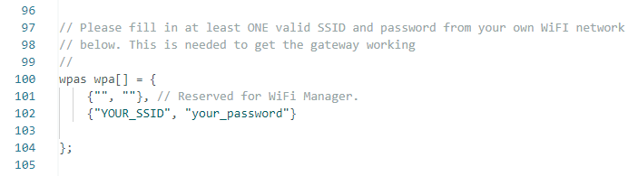

Gateway ID & GPS Positioning of the Gateway
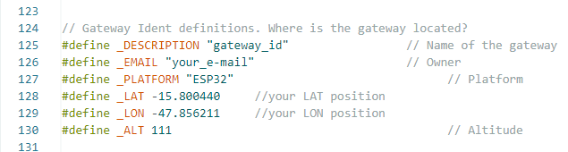

File
configGway.h

Set your Gateway Device Single Channel
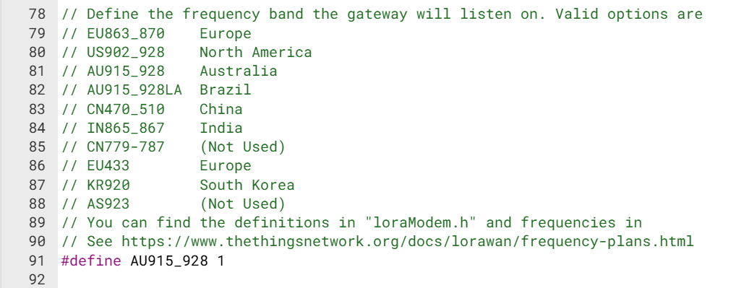

Set your Pins Device
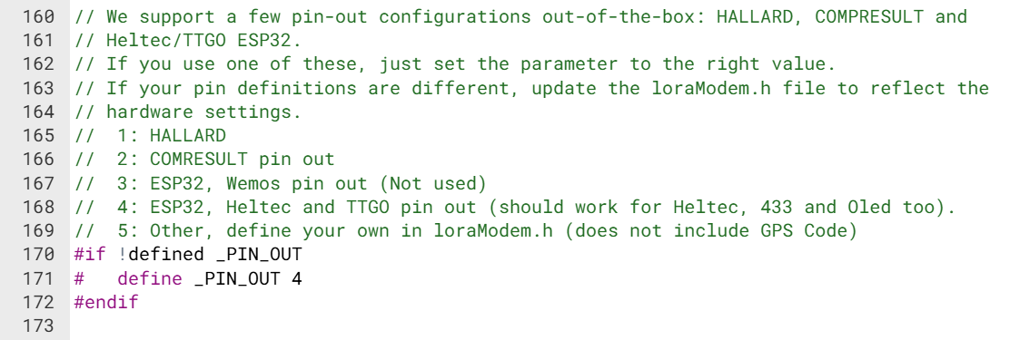

Disable the Display Oled, if necessary.
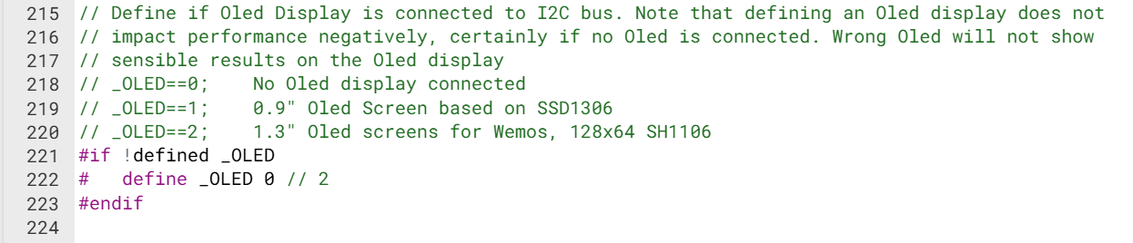

In Case of no Compilation in Platform Arduino
File
_utils.ino
Line 475, replace the variable type from “byte” to “uint8_t”
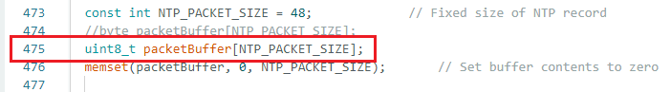

File

ESP-sc-gway.ino => Set here again your Pins Device
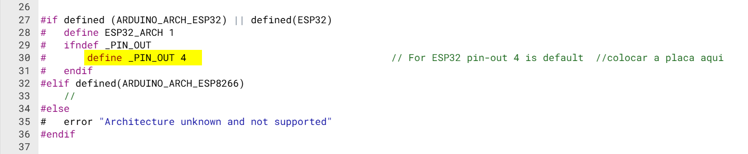

Control the command WiFi.setAutoReconnect(true);
In case of wrong command WiFi.setAutoConnect(true);
Modify to WiFi.setAutoReconnect(true);
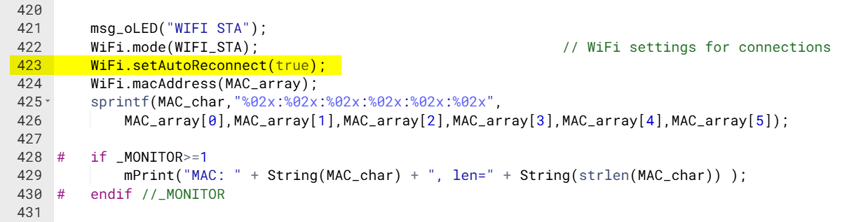

Arduino => Board Manager
GitHub - espressif/arduino-esp32: Arduino core for the ESP32 · GitHub
esp32 by Espressif => Vs. 2.0.17
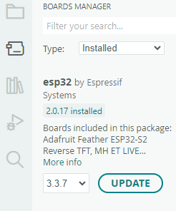

Arduino => File => Preferences…
Additional Boards Manager URLs:
https://raw.githubusercontent.com/espressif/arduino-esp32/gh-pages/package_esp32_index.json
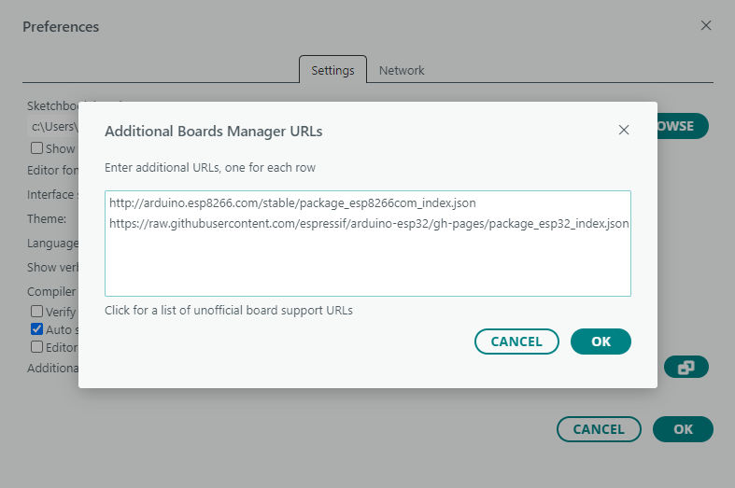

Bibliotecas e Versões necessárias:

Adafruit_BusIO => Vs 1.17.4
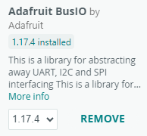

Adafruit-GFX-Library => Vs 1.12.4
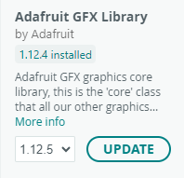

Adafruit_NeoPixel => Vs 1.9.0
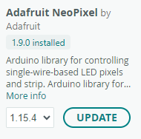

Adafruit_SSD1306 => Vs 2.5.16
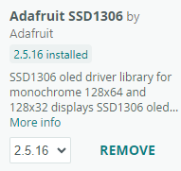

ArduinoJson: Efficient JSON serialization for embedded C++
Arduinojson => Vs 7.4.3
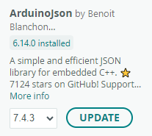

GitHub - suculent/esp32-http-update: Clone of https://github.com/esp8266/Arduino/tree/master/libraries/ESP8266httpUpdate for ESP32 · GitHub
ESP32httpUpdate => Vs 2.1.145
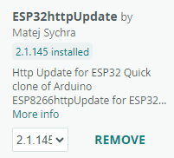

GitHub - ThingPulse/esp8266-oled-ssd1306: Driver for the SSD1306 and SH1106 based 128x64, 128x32, 64x48 pixel OLED display running on ESP8266/ESP32 · GitHub
ESP8266 and ESP32 OLED driver for… => Vs. 4.4.1
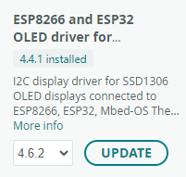

HotButton => Vs. 0.1.1
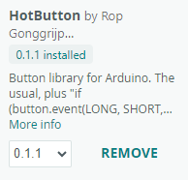

GitHub - mcci-catena/arduino-lmic: LoraWAN-MAC-in-C library, adapted to run under the Arduino environment · GitHub
MCCI LoRaWAN LMIC library => Vs. 4.1.1
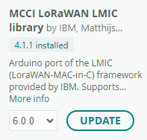

GitHub - ropg/LoRaWAN_ESP32: ESP32 persistence (deep sleep) code for RadioLib LoRaWAN. Can also manage provisioning data · GitHub
LoRaWAN_ESP32 => Vs. 1.2.0
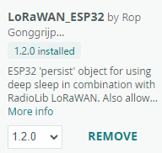

GitHub - janelia-arduino/Streaming: Streaming C++-style Output with Operator << · GitHub
Streaming => Vs. 5.0.0
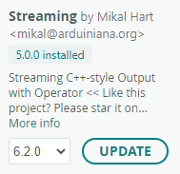

Arduino Playground - Time
Time => Vs. 1.6
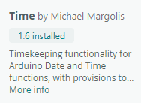

GitHub - tzapu/WiFiManager: ESP8266 WiFi Connection manager with web captive portal · GitHub
WiFiManager => Vs 2.0.16-rc-2
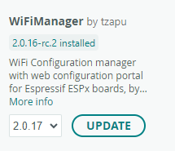

GitHub - Densaugeo/base64_arduino: Base64 encoder/decoder for arduino repo · GitHub
base64 => Vs. 1.0.0
